Lab 4: Docker port expose

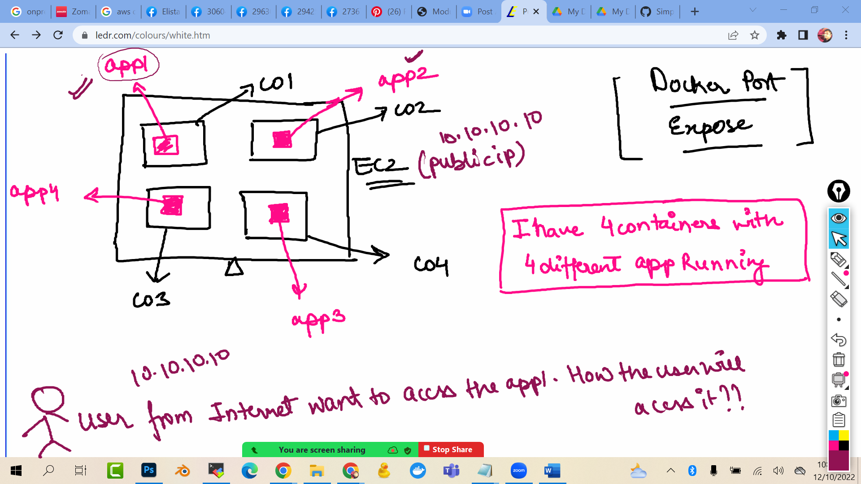

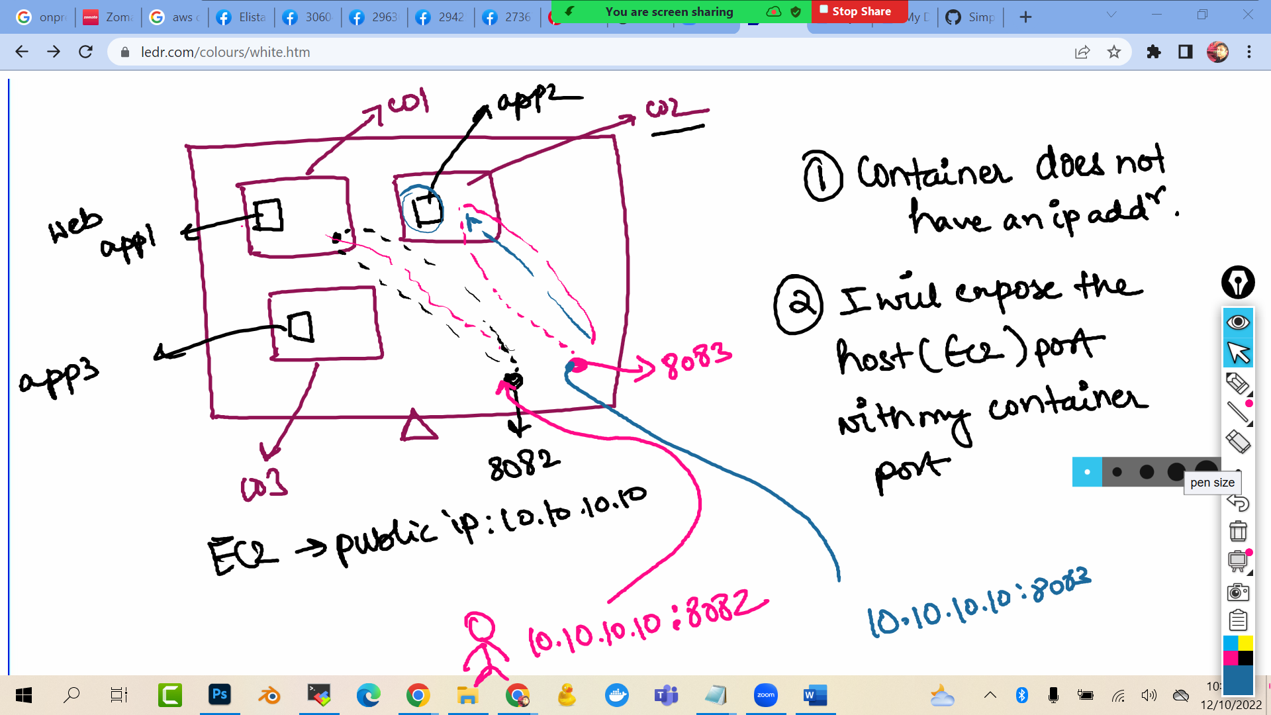

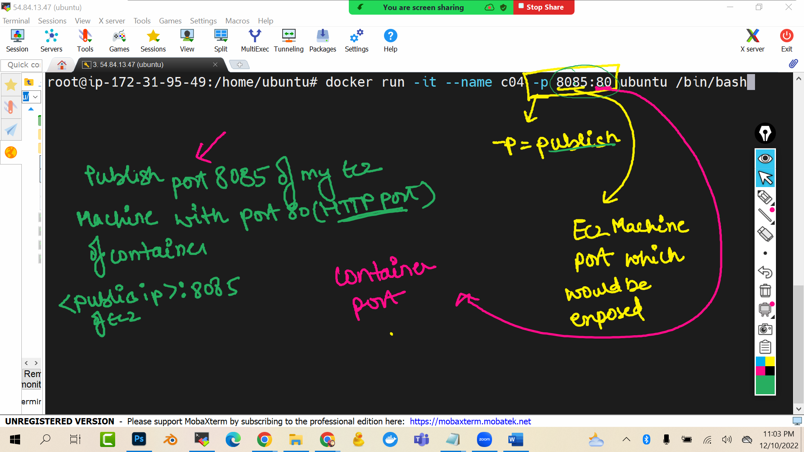

docker run -it --name c04 -p 8085:80 ubuntu /bin/bash

(this command will expose port 8085 of ec2 machine with port 80 (which is http port) of my container)



Currently we have created a ubuntu container….i want to launch a website in that ubuntu container so I will install apache2 in ubuntu container …what is apache? Apache the webserver

apt update -y

apt install apache2 -y

service apache2 start

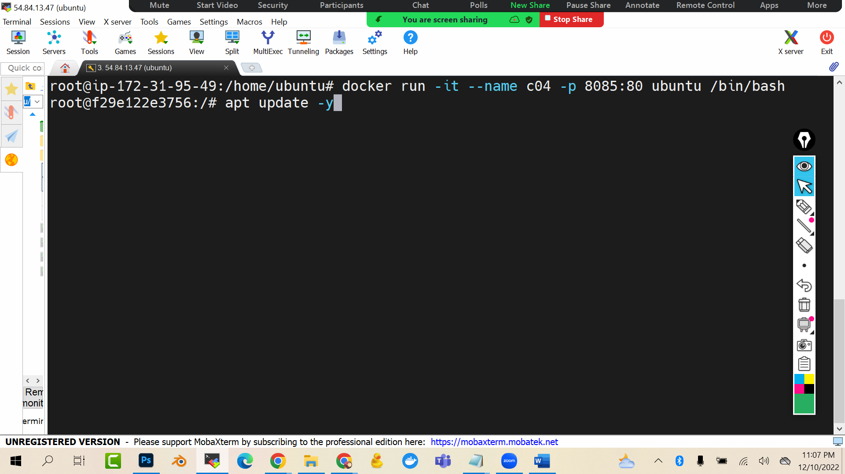

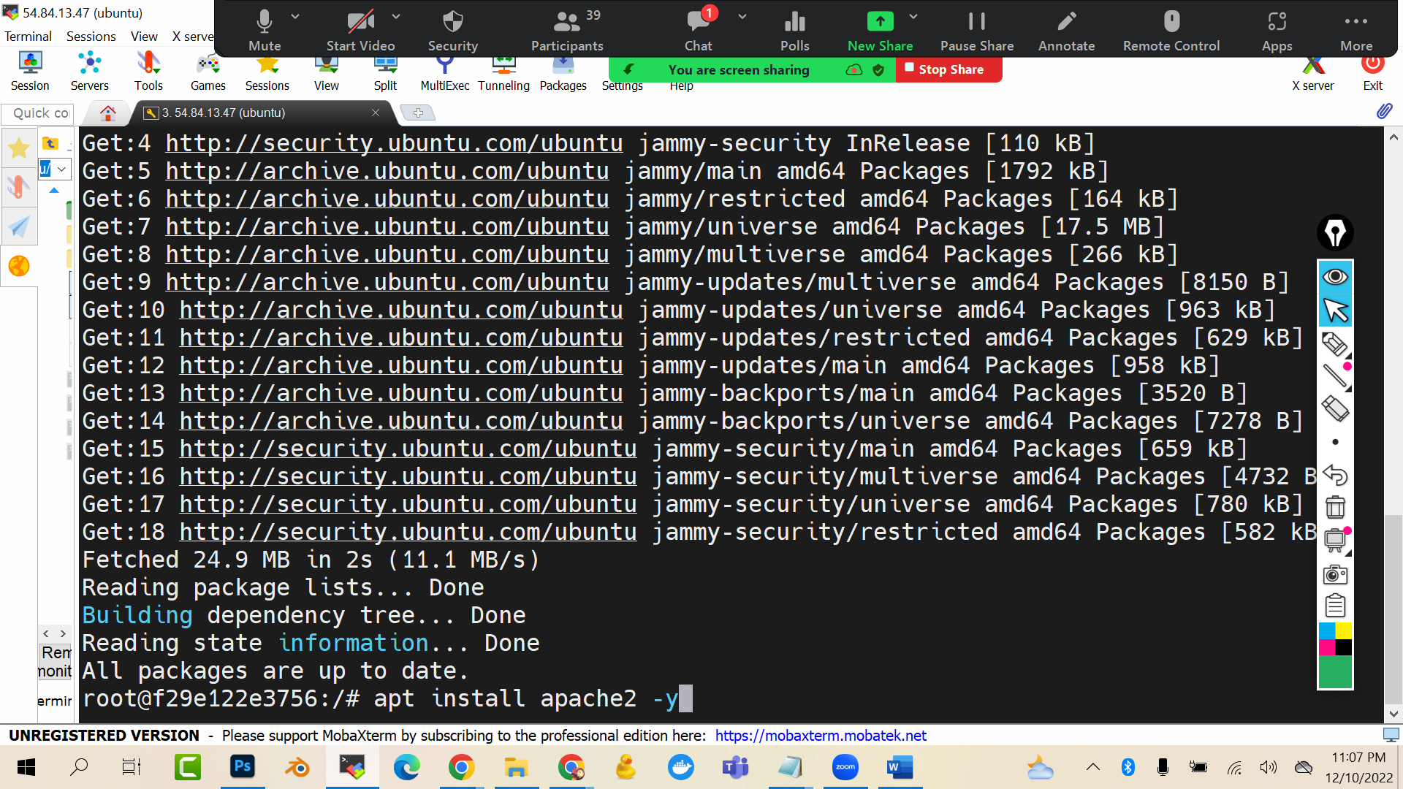

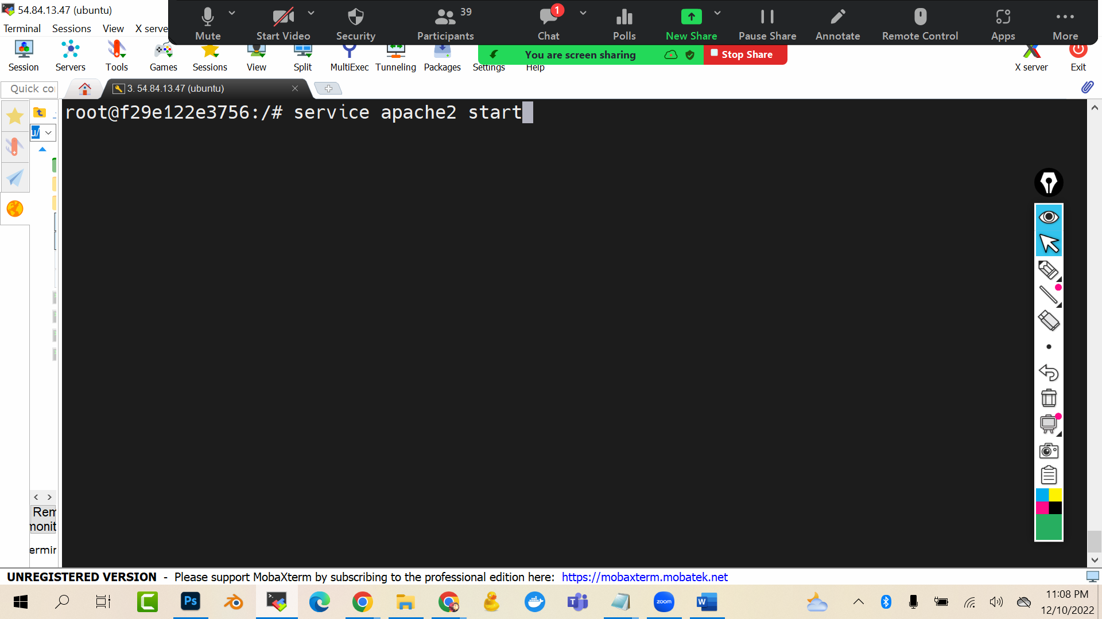

Now I will go to the ec2 machine and enable the port 8085 of the machine

Because if I will not do so the firewall of ec2 will not allow me to communicate via port 8085

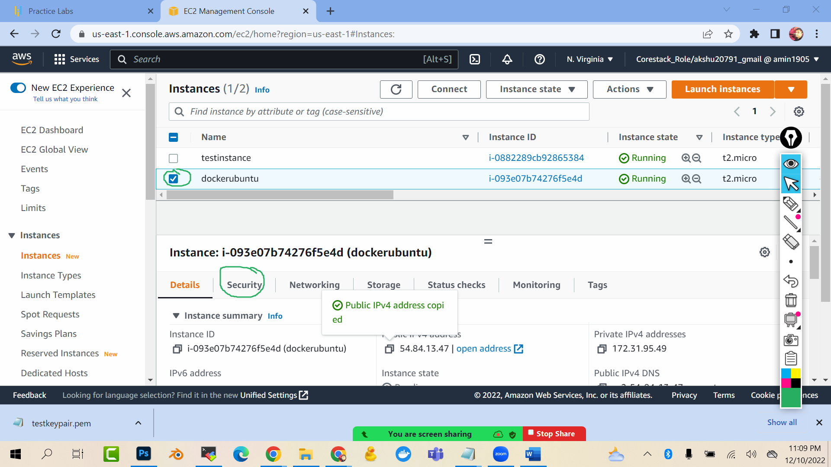

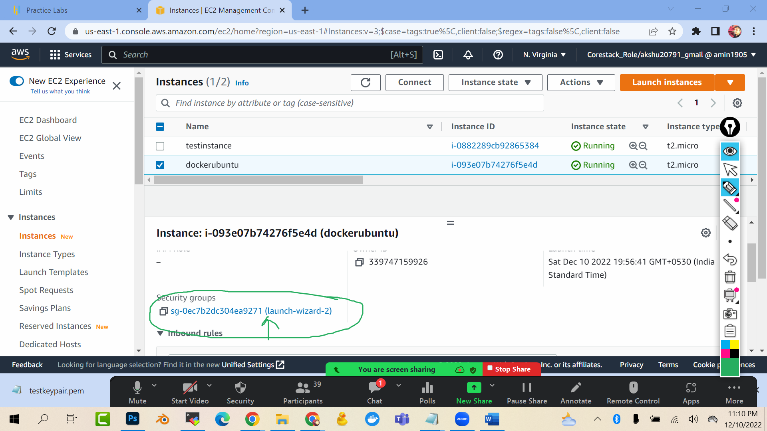

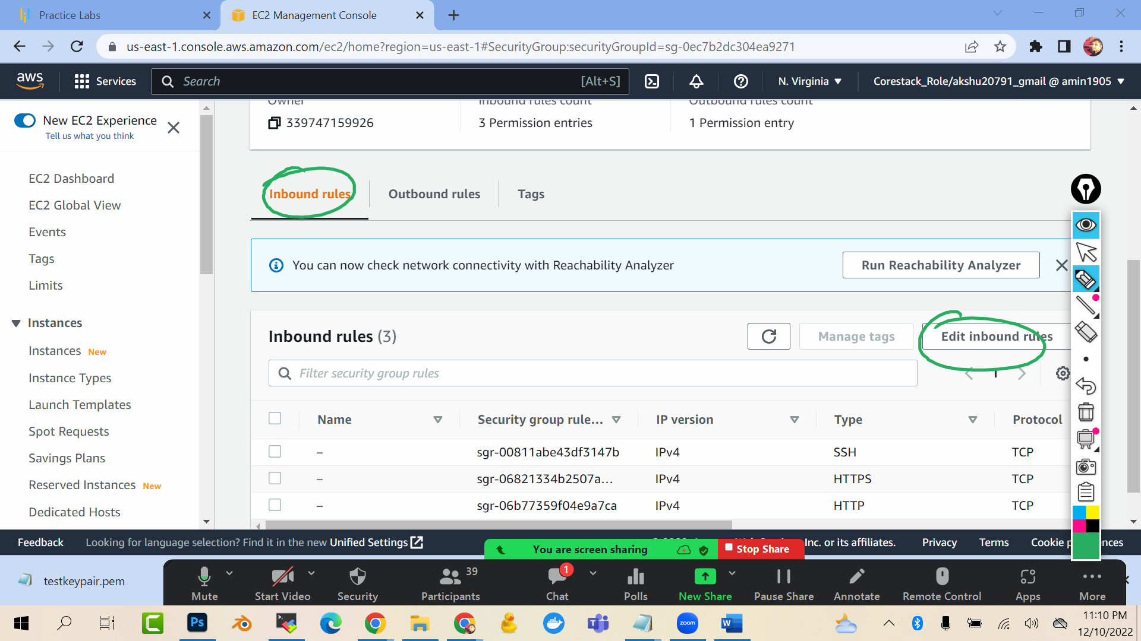

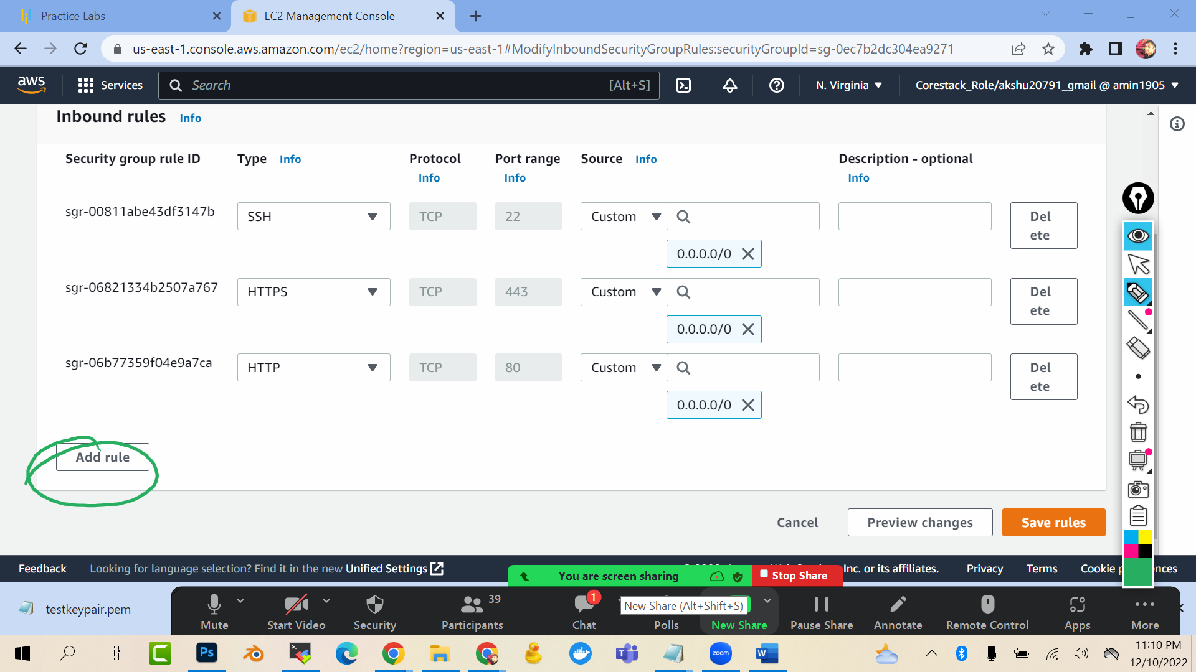

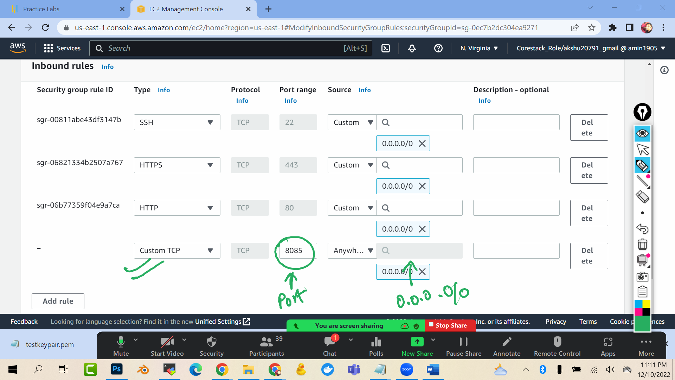

Save rule

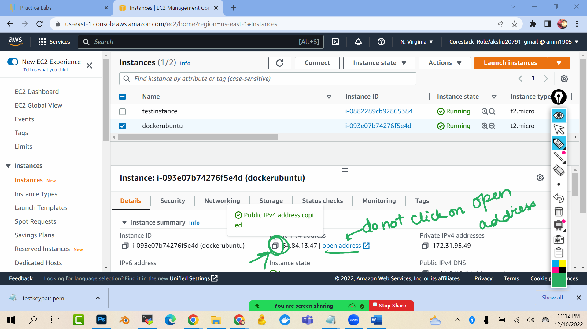

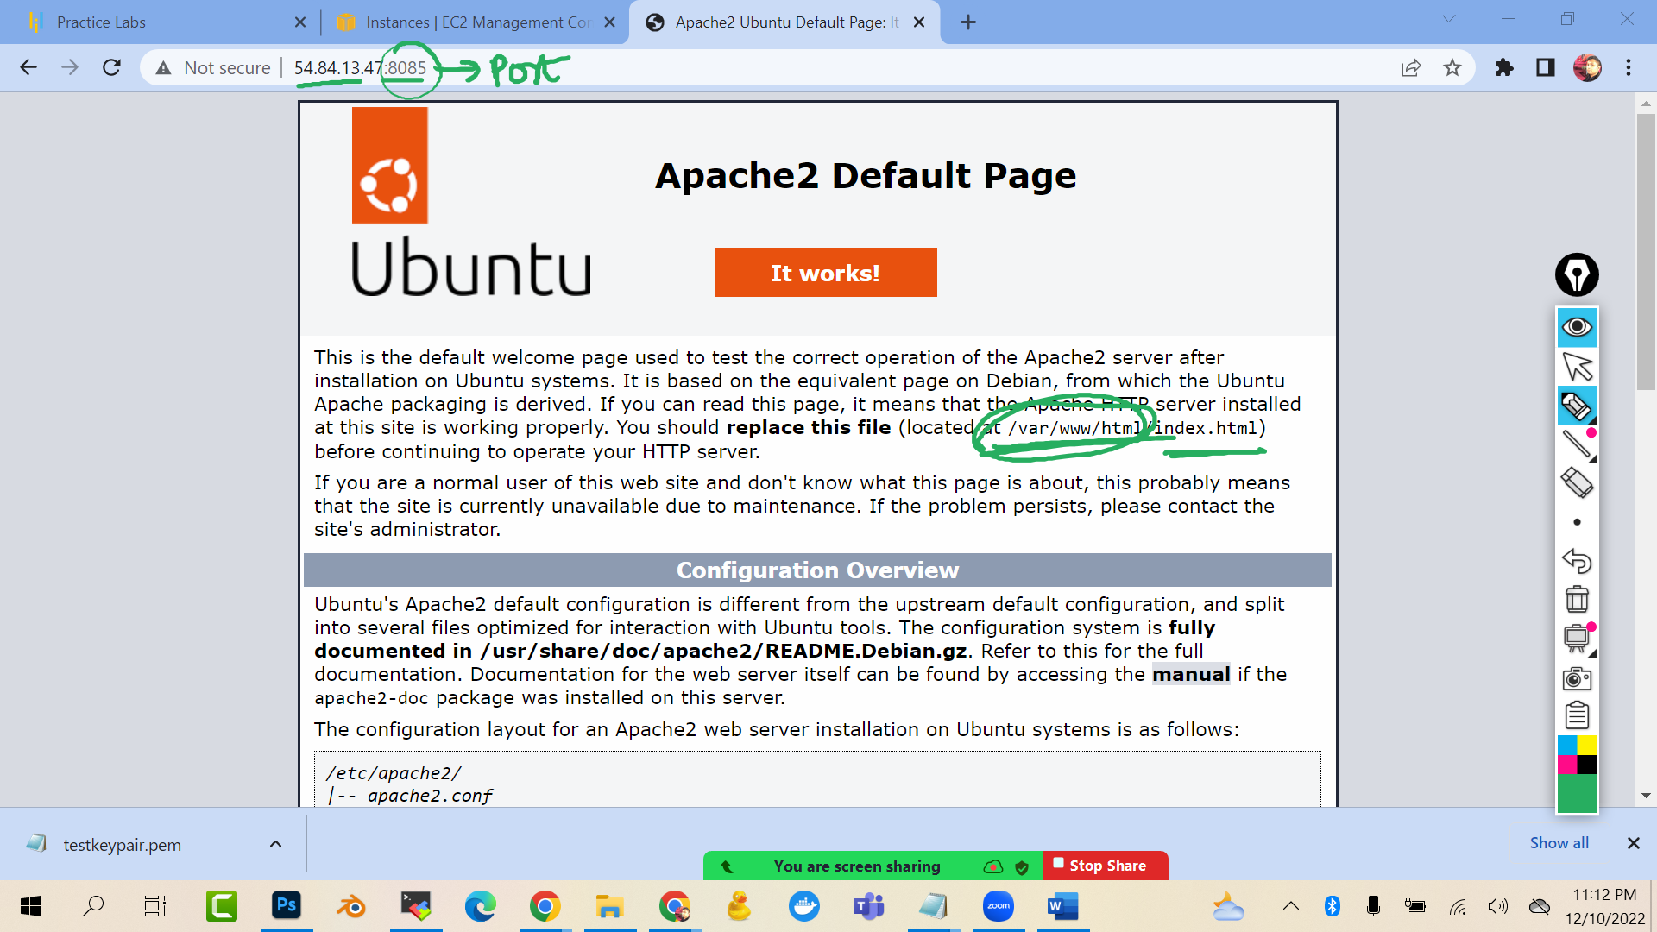

cd /var/www/html/

cat >index.html

hello world this is learning

(press ctrl d)

